**EXPERIMENTAL REPORT**

2020A0576: Structural investigation of novel high-temperature superconductors: ternary lanthanum polyhydrides

Dmitrii Semenok, Ivan Troyan, Anna Ivanova, Di Zhou, Yuki Nakamoto and Katsuya Shimizu

**Research goals**

Within this project we proposed to study ternary polyhydrides of lanthanum synthesized in high-pressure diamond anvil cells (DAC) using NH3BH3 as a source of hydrogen. It was planned to investigate all newly found phases by synchrotron X-ray to determine their crystal structure, phase transformations and equations of state. Within this proposal, we we intended to study the crystal structure of hydrides in La-Ca-H, La-Mg-H, La-Sr-H and La-Nd-H ternary systems, however, due to recent travel restrictions our plans has been changed. Thus, only 2 DACs: 1) M1, loaded by La-Nd alloy with ~9 at. % of Nd, and 2) M2, where La was replaced by Y, and Ca-Y alloy (1:1) was loaded in the diamond anvil cell.

**Results**

The parameters of diamond anvil cells M1 and M2, loaded by La0.91Nd0.09 and CaY respectively, are given in Table 1. The La-Nd alloy for the loading of DAC M1 was prepared by an arc melting (2000-2500 oC, 10 seconds) of La/Nd pellets in Ar atmosphere at pressure of 1 bar. Then, this alloy was investigated by scanning electron microscopy. Measurements of the X‑ray energy dispersive spectra (EDS) were performed on FEI Quanta 200 3D scanning electron microscope (SEM) with EDAX Genesys setup (Figure 2). According to the results of the energy-dispersive analysis, the obtained alloy contains about 8.5-9.5 at. % of Nd.

**Table 1.** Experimental parameters of the DACs used for the X‑ray diffraction studies. Data in the second column corresponds to the pressure of the laser-assisted synthesis.

|  |  |  |  |
| --- | --- | --- | --- |
| #cell | Pressure, GPa | Sample size, μm | Composition |
| M1 | 170 | 30 | La0.91Nd0.09/BH3NH3 |
| M2 | 171 | 35 | CaY/BH3NH3 |

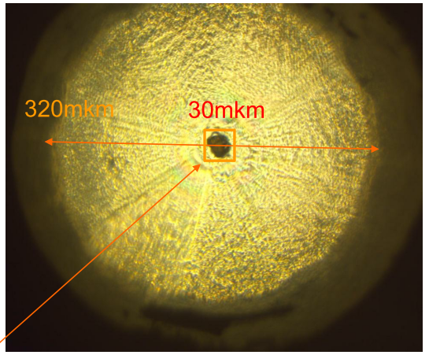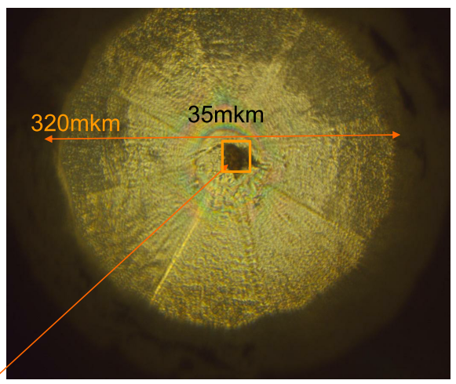

**Figure 1.** Optical photography of diamond anvils of DACs M1 (**left**, at 170 GPa) and M2 (**right**, at 171 GPa).

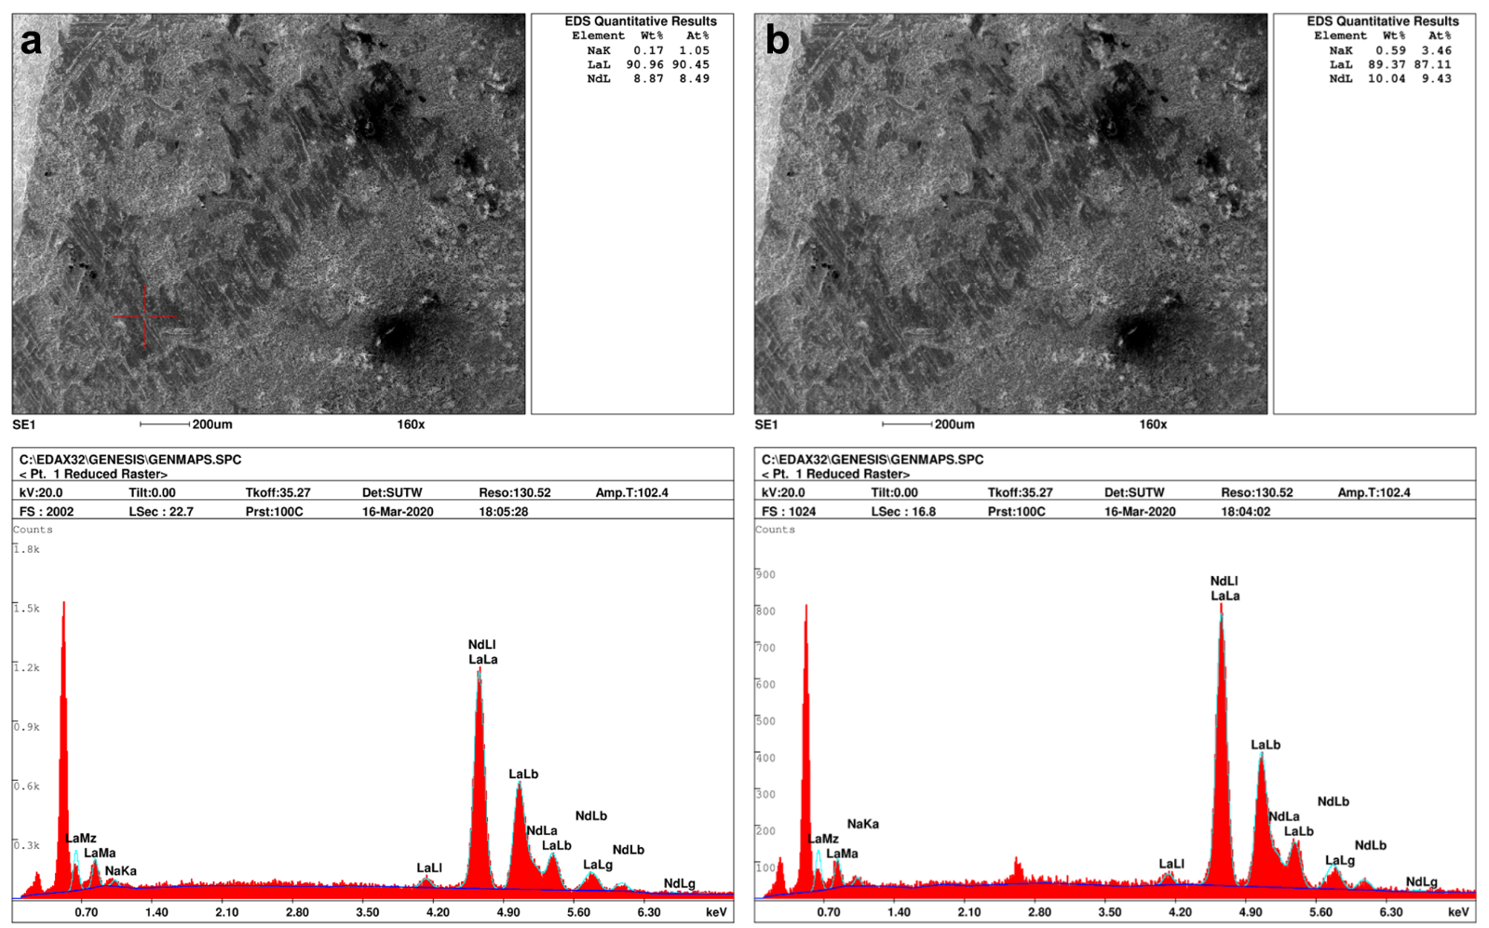  
**Figure 2 (a, b).** SEM images of the initial La-Nd alloy at 0 GPa and EDX spectra from two different points of the sample.

Pulsed laser heating of La-Nd and Ca-Y micro samples mixed with NH3BH3, was carried out at 1500-2000 K with duration of several hundred microseconds. After the heating the metal particles expanded, became black, and the pressure in DACs, measured via both Raman signals of diamond and hydrogen, was 170 ±1 GPa. However, during the cells transportation, the pressure in M1 spontaneously rose to 202 GPa. Within this work the pressure in the DACs was determined via the Raman signal of diamond [Eremets, M. I., *J. Raman Spectrosc.* 34, 515–518 (2003)] as shown in Figure 3.

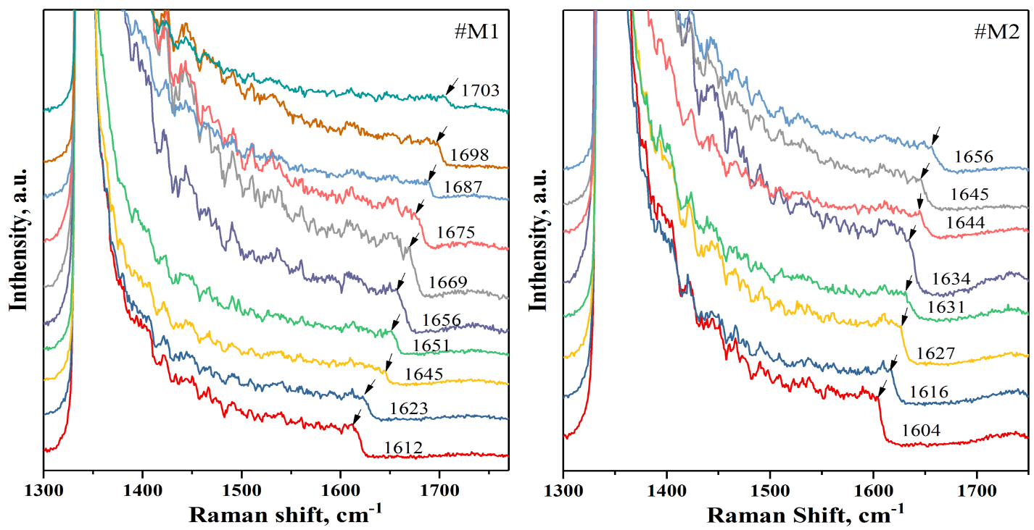

**Figure 3.** Raman spectra of the DAC M1 recorded during decompression. The numbers in the figure indicate the frequency of Raman signal of diamond in cm-1.

Results of the high-pressure synthesis were examined through powder X-ray diffraction of synchrotron radiation with wavelength of 0.413 Å (Table 2, Figures 4-5). In the M1 cell the main phase was *Fm-3m*-La0.91Nd0.09H10 witha cell volume ~30.3 Å3 per metal atom at 200 GPa, slightly lower than the cell volume of *Fm-*3*m*-LaH10 (Figure 5a). There is also another impurity phase (marked as *) with low hydrogen content the structure of which remains to be determined.

In the M2 DAC we found only one phase: cubic (Ca,Y)H9+x, unit cell volume 28.59 Å3 per metal atom at 155 GPa, Table 2, Figure 3b) which corresponds to slightly distorted *Fm-*3*m* (or *F-43m* or *R*-3*m*) structure with (Ca,Y):H 1 : 9+x (where x=-0.2...+0.5) ratio. Equation of state V(P) of this phase is quite close to *Fm-*3*m*-YH10 and *P*63*/mmc*-YH9 (see Figure 5b). This makes the study of superconductivity in this ternary hydride very promising.

**Table 2.** Experimentallattice parameters and unit cell volumes of ‑ La0.91Nd0.09H10 (Z=4) and distorted ‑(Ca,Y)H9+x (*Z*= 4, x= -0.2 … +0.5).

|  |  |  |  |  |  |  |  |  |
| --- | --- | --- | --- | --- | --- | --- | --- | --- |
| **DAC M1** | | | | **DAC M2** | | | | |
| Pressure, GPa | *a*, Å | *V*, Å3 | *Vmetal*, Å3 | Pressure, GPa | *a*, Å | *V*, Å3 | *Vmetal*, Å3 |
| 143 | 5.1047 | 133.01 | 33.25 | 135 | 4.8958 | 117.34 | 29.33 |
| 148 | 5.0896 | 131.84 | 32.95 | 143 | 4.8779 | 116.06 | 29.01 |
| 159 | 5.0578 | 129.39 | 32.34 | 149 | 4.8597 | 114.77 | 28.69 |
| 167 | 5.0440 | 128.33 | 32.08 | 155 | 4.8543 | 114.39 | 28.59 |
| 172 | 5.0250 | 126.88 | 31.721 | 161 | 4.8529 | 114.29 | 28.57 |
| 178 | 5.0103 | 125.77 | 31.44 | 168 | 4.8492 | 114.03 | 28.51 |
| 184 | 4.9989 | 124.92 | 31.22 |  |  |  |  |
| 190 | 4.9827 | 123.71 | 30.92 |  |  |  |  |
| 197 | 4.9665 | 122.51 | 30.62 |  |  |  |  |
| 202 | 4.9344 | 120.15 | 30.03 |  |  |  |  |

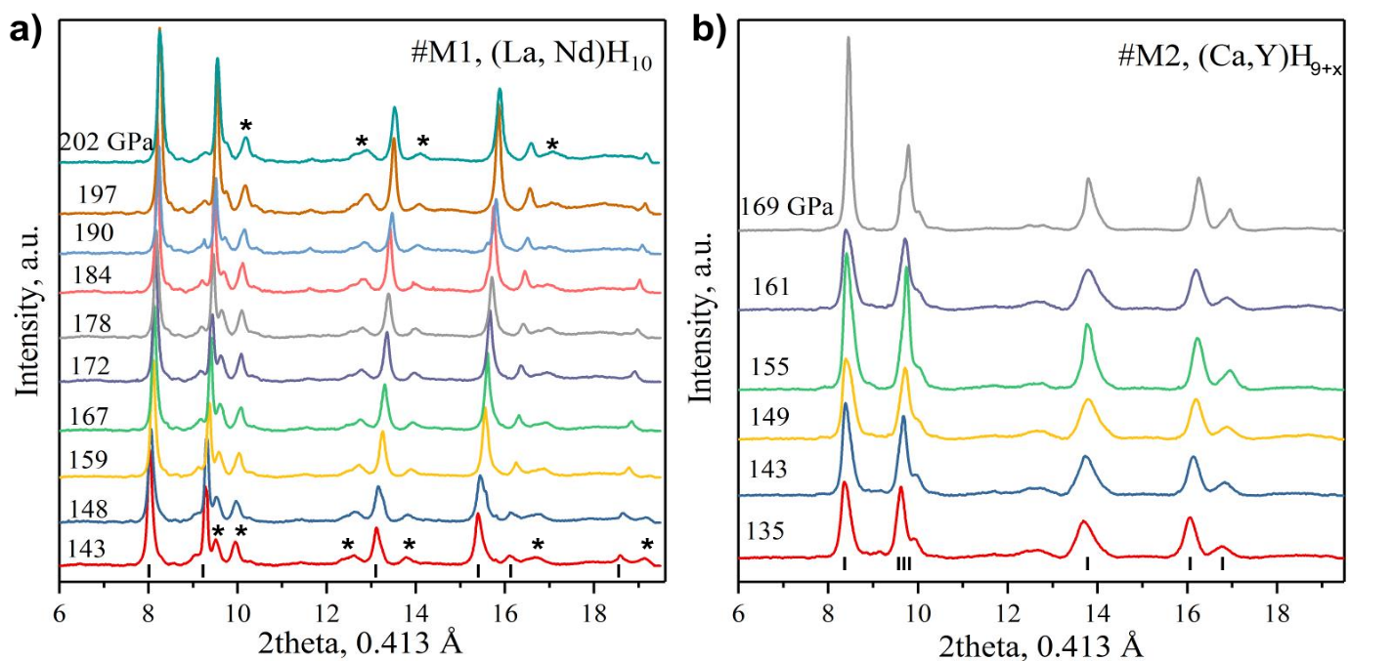

**Figure 4.** Experimental XRD patterns from M1 (a) and M2 (b) cells in the pressure range from 202 to 143 GPa and from 169 to 135 GPa (decompression), respectively. Unexplained weak reflections are marked by asterisks.

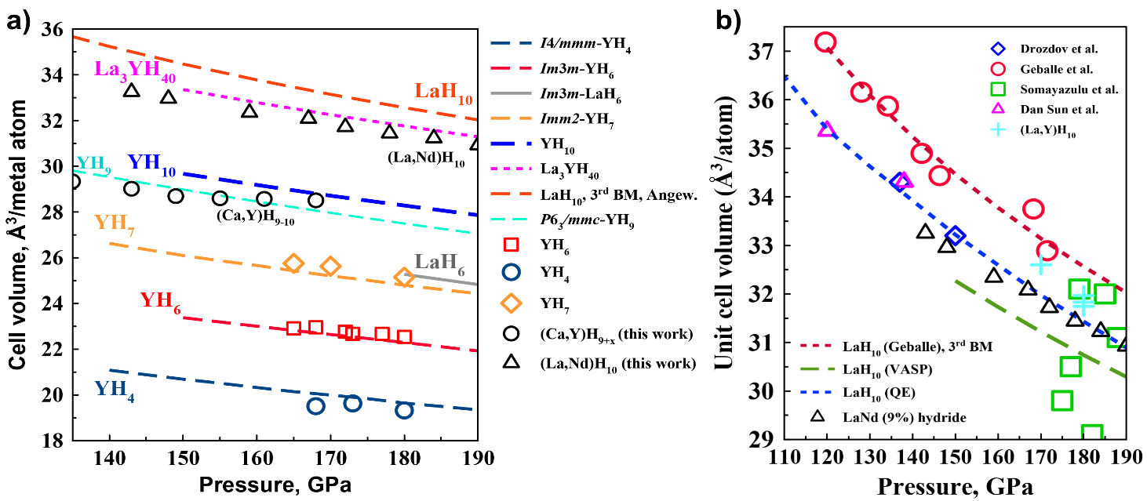

**Figure 5 (a, b).** Pressure–unit cell volume diagram for La,Y polyhydrides: circles (black: (Ca,Y)H9+x), squares, rhombuses, triangles (black: La0.91Nd0.09H10), and crosses show the experimental data, lines depict the theoretical calculations.

Superconducting properties of the synthesized lanthanum-neodymium superhydride have also been investigated at pressure 180 GPa (Figure 6). Measurements of the electrical resistivity in an external magnetic field (0-16 T) show that the introduction of only 9 at. % of neodymium into lanthanum reduces the *T*C by 100 K in comparison with pure LaH10 (from 250 K to 148 K). Simultaneously, the superconducting transition is broadened to Δ*T*C ~ 30 K, and reduces the upper critical field *H*C2(0) to 60-67 T, which is in good agreement with the phonon coupling mechanism and predictions of Migdal-Eliashberg theory of superconductivity.

This work shows how important role the impurities of other rare earth metals play. Thorough purification of La from impurities of other lanthanides is an important step towards achieving the maximum critical temperature in LaH10. Our work also demonstrates that the mechanism of superconductivity in superhydrides is not associated with any magnetic phenomena or ordering.

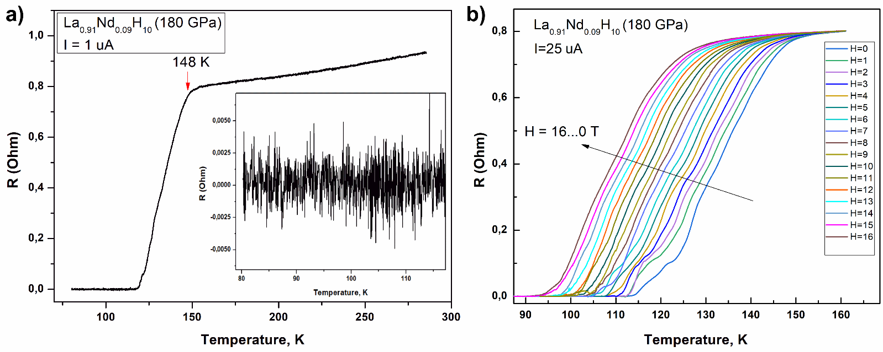  
**Figure 6.** Superconducting transitions in *Fm-3m*-La0.91Nd0.09H10 at 180 GPa: (a) temperature dependence of the electrical resistance for the sample in absence of magnetic field. (b) Dependence of the electrical resistance of La0.91Nd0.09H10 on the external magnetic field (0–16 T) at 180 GPa and 25 µA current. An estimate of the Debye temperature from the temperature dependence of the electrical resistance of the sample gives θD = 950 ± 25 K.

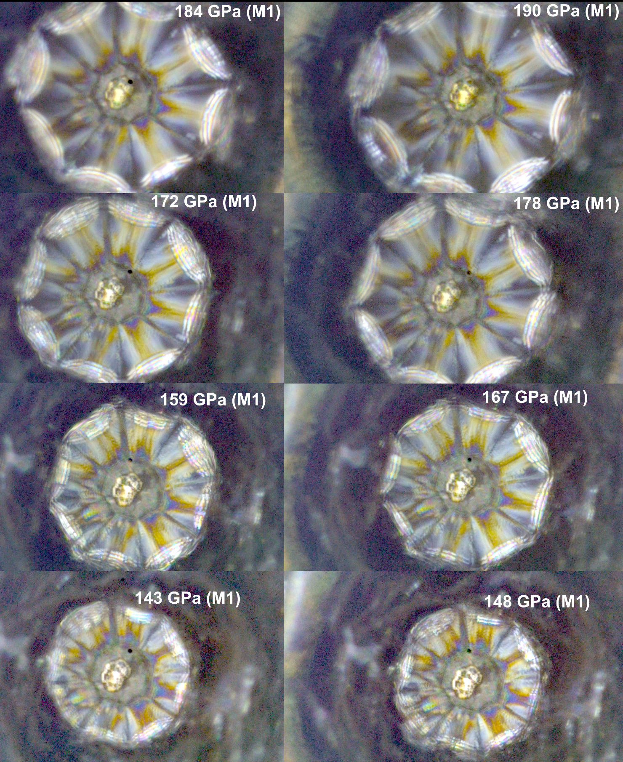

**Figure 7.** Optical photography of diamond anvil culet of DAC M1 loaded with the La–Nd alloy and AB within sequential decompression of the cell. The sample retains its characteristic metallic luster at all pressures. The black dot indicates the location where the pressure was measured.

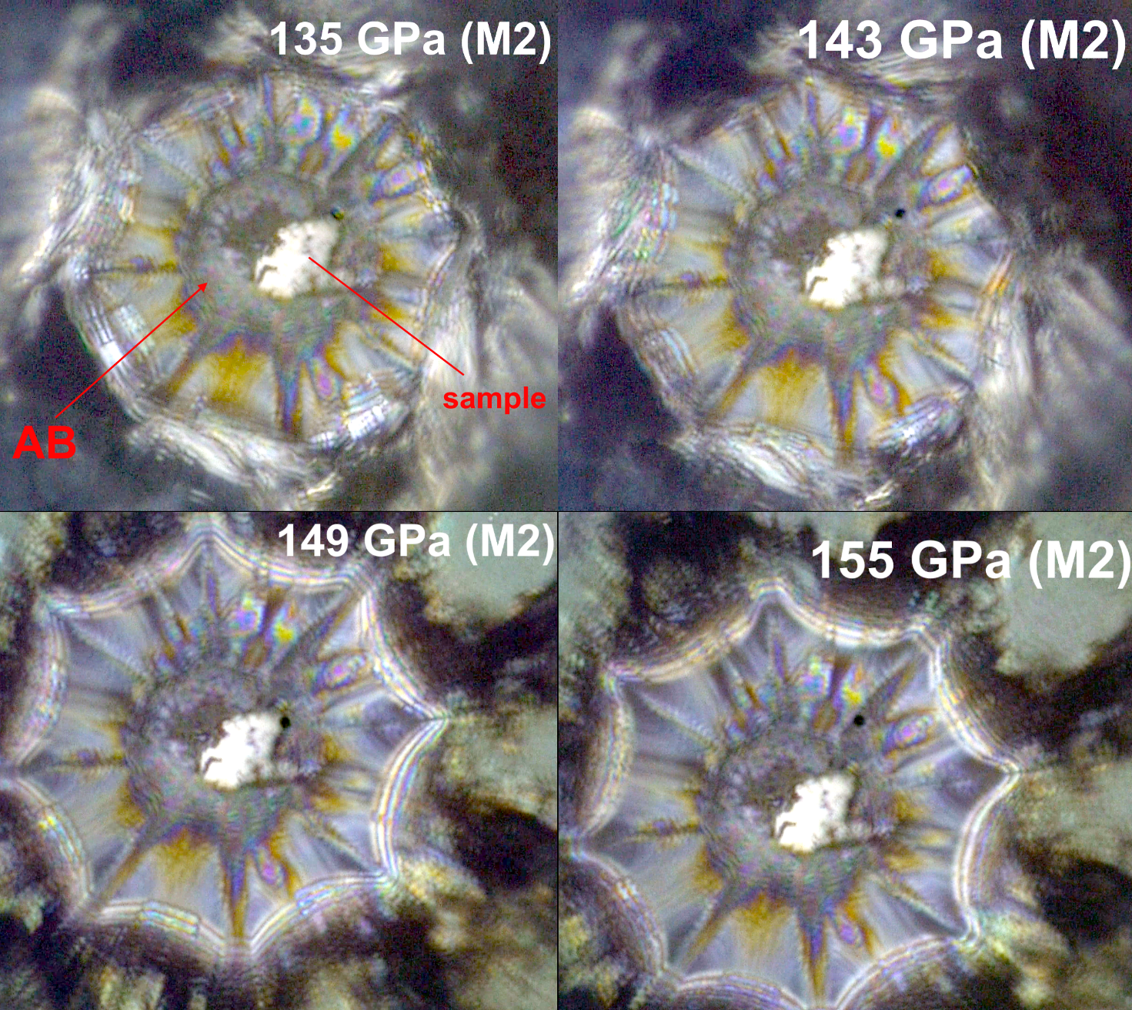

**Figure 8.** Optical photography of diamond anvil culet of DAC M2 loaded with the Ca–Y alloy and AB within sequential decompression of the cell. The black dot indicates the location where the pressure was measured.

A few notes should be made on the Le Bail refinement (Figures 9-22) of the (Ca,Y)H9+x unit cell parameters. The refinement using pseudocubic *P1*-(Ca,Y)H9+x gives the best agreement with the experiment. In this case, the unit cell volume V(P) is practically independent of pressure. This is possible if, at the same time as the pressure decreases, the compound loses some of hydrogen. This situation was previously observed for cerium hydride CeH9 [Xin Li et al. *Nature Communications* 10, 3461 (2019)]. However, if the refinement is carried out using a cubic structure of the *Fm-3m*-LaH10 type, then the cell volume naturally increases with decreasing pressure. But the agreement with the experimental data turns out to be much worse. For this reason, we included both type of refinements in our report.

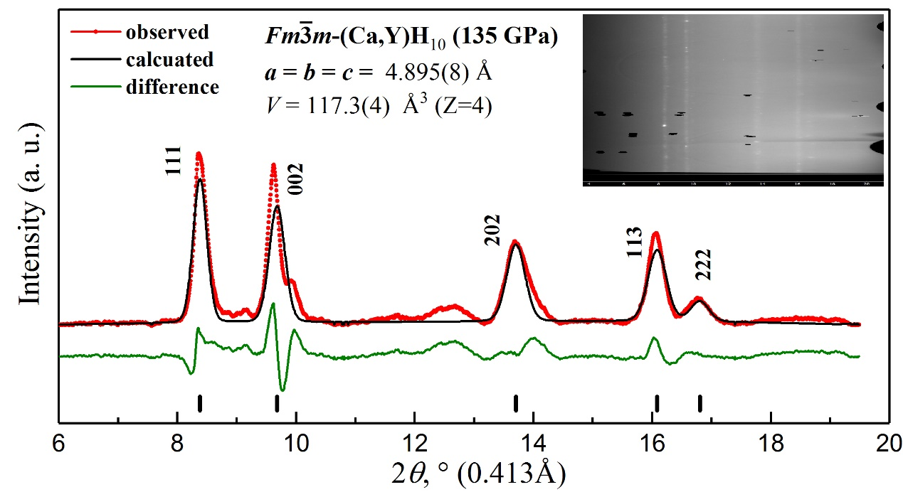

**Figure 9.** Le Bail refinement of *Fm $\overline{3}$ m*‑(Ca,Y)H9+x and the experimental XRD pattern at 135 GPa (DAC M2). The experimental data, model fit for the structure, and residues are shown in red, black, and green, respectively.

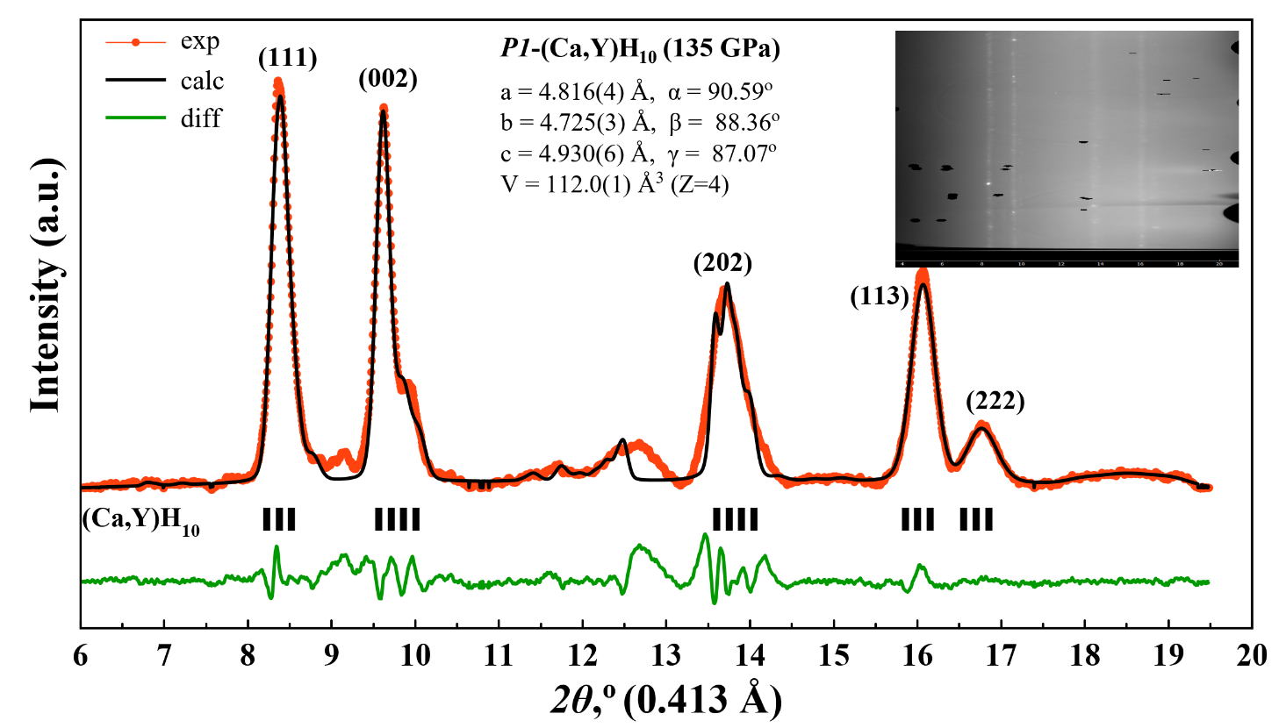

**Figure 10.** Le Bail refinement of *P1*‑(Ca,Y)H9+x and the experimental XRD pattern at 135 GPa (DAC M2). The experimental data, model fit for the structure, and residues are shown in red, black, and green, respectively.

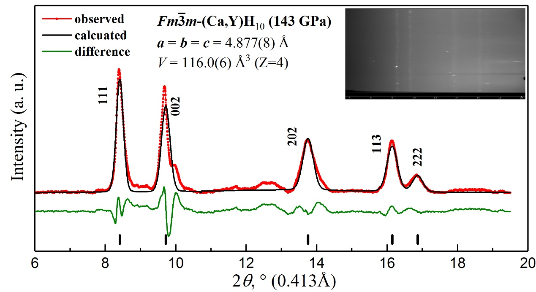

**Figure 11.** Le Bail refinement of *Fm $\overline{3}$ m*‑(Ca,Y)H9+x and the experimental XRD pattern at 143 GPa (DAC M2). The experimental data, model fit for the structure, and residues are shown in red, black, and green, respectively.

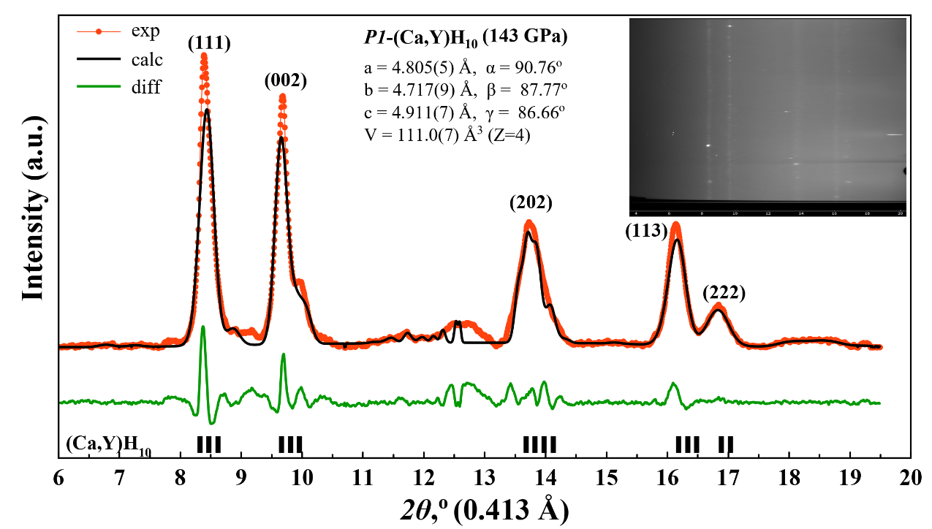

**Figure 12.** Le Bail refinement of *P1*‑(Ca,Y)H9+x and the experimental XRD pattern at 143 GPa (DAC M2). The experimental data, model fit for the structure, and residues are shown in red, black, and green, respectively.

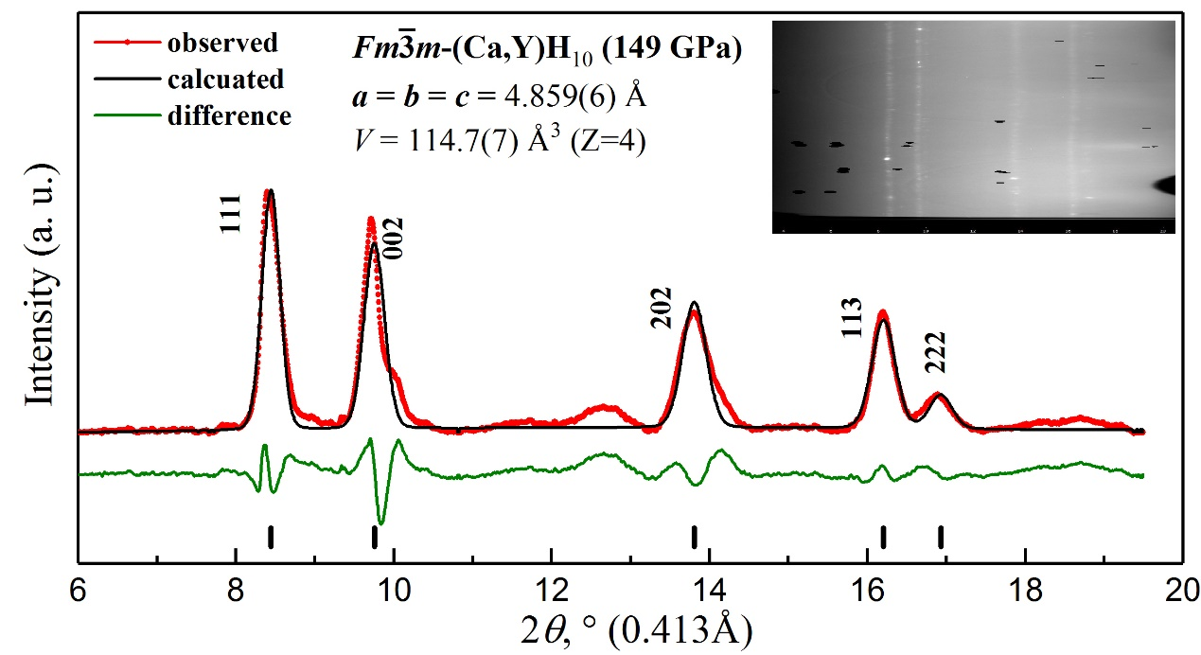

**Figure 13.** Le Bail refinement of *Fm $\overline{3}$ m*‑(Ca,Y)H9+x and the experimental XRD pattern at 149 GPa (DAC M2). The experimental data, model fit for the structure, and residues are shown in red, black, and green, respectively.

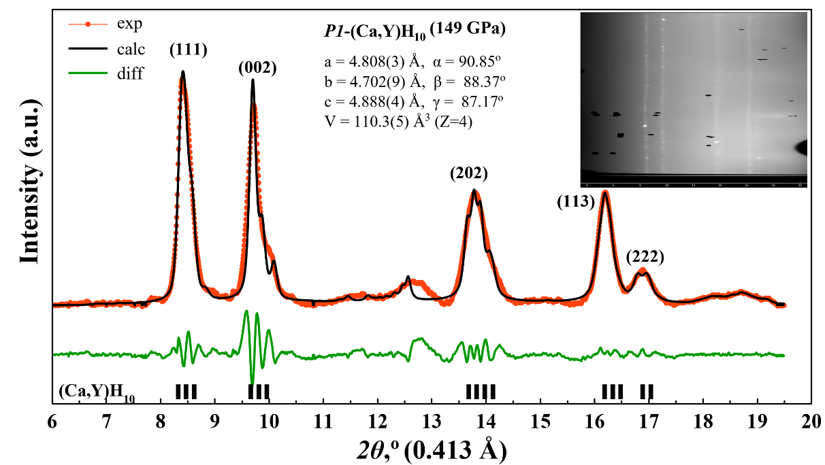

**Figure 14.** Le Bail refinement of *P1*‑(Ca,Y)H9+x and the experimental XRD pattern at 149 GPa (DAC M2). The experimental data, model fit for the structure, and residues are shown in red, black, and green, respectively.

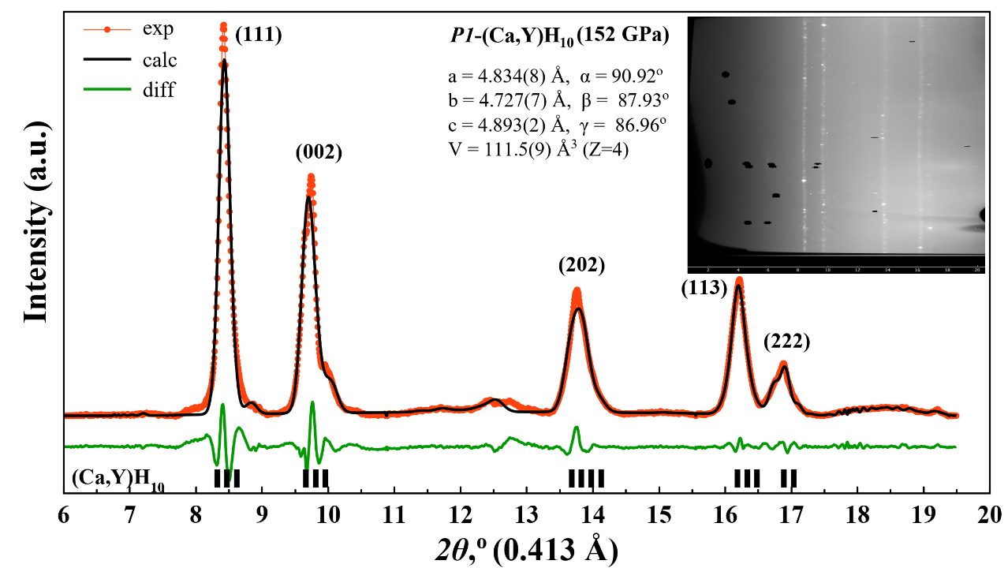

**Figure 15.** Le Bail refinement of *P1*‑(Ca,Y)H9+x and the experimental XRD pattern at 152 GPa (DAC M2). The experimental data, model fit for the structure, and residues are shown in red, black, and green, respectively.

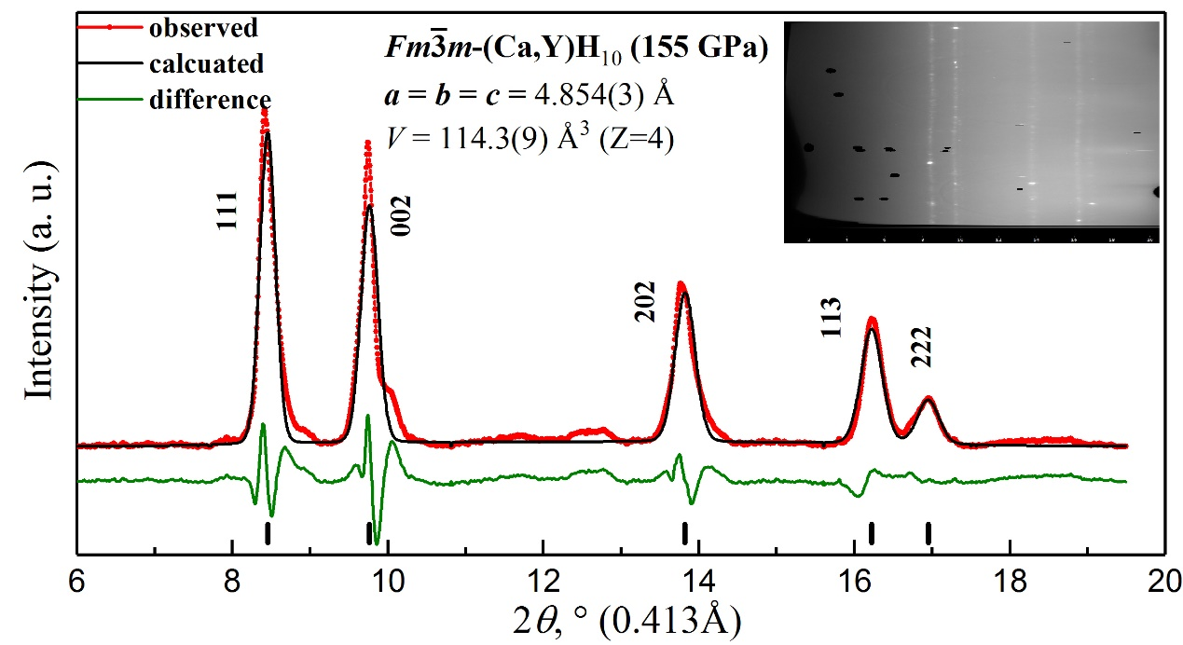

**Figure 16.** Le Bail refinement of *Fm $\overline{3}$ m*‑(Ca,Y)H9+x and the experimental XRD pattern at 155 GPa (DAC M2). The experimental data, model fit for the structure, and residues are shown in red, black, and green, respectively.

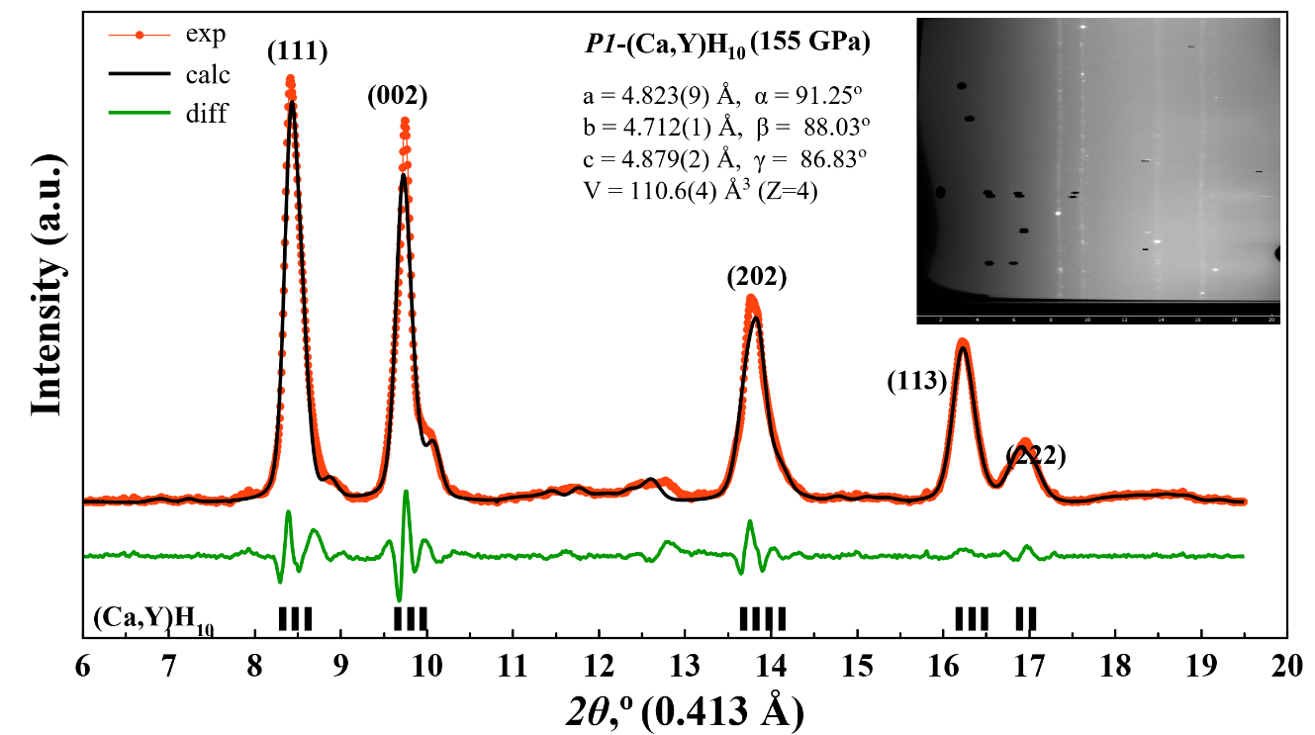

**Figure 17.** Le Bail refinement of *P1*‑(Ca,Y)H9+x and the experimental XRD pattern at 155 GPa (DAC M2). The experimental data, model fit for the structure, and residues are shown in red, black, and green, respectively.

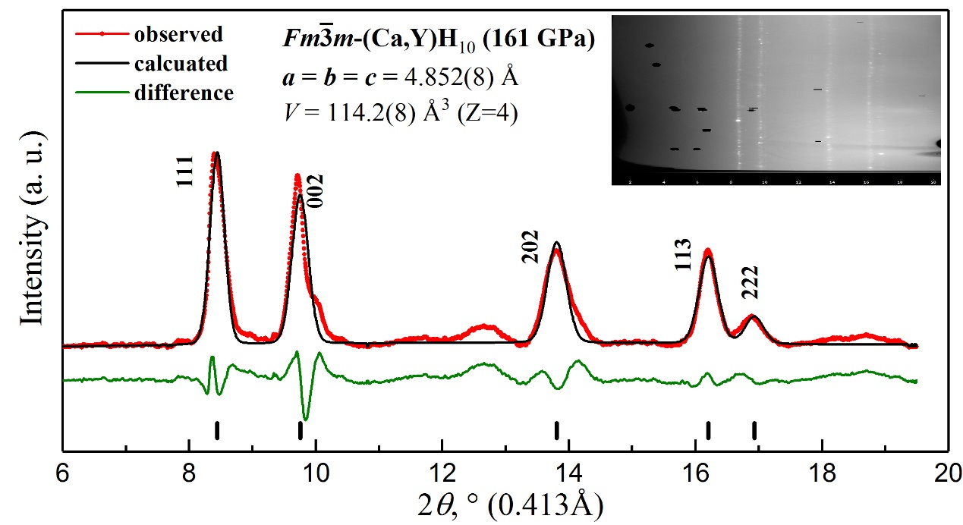

**Figure 18.** Le Bail refinement of *Fm $\overline{3}$ m*‑(Ca,Y)H9+x and the experimental XRD pattern at 161 GPa (DAC M2). The experimental data, model fit for the structure, and residues are shown in red, black, and green, respectively.

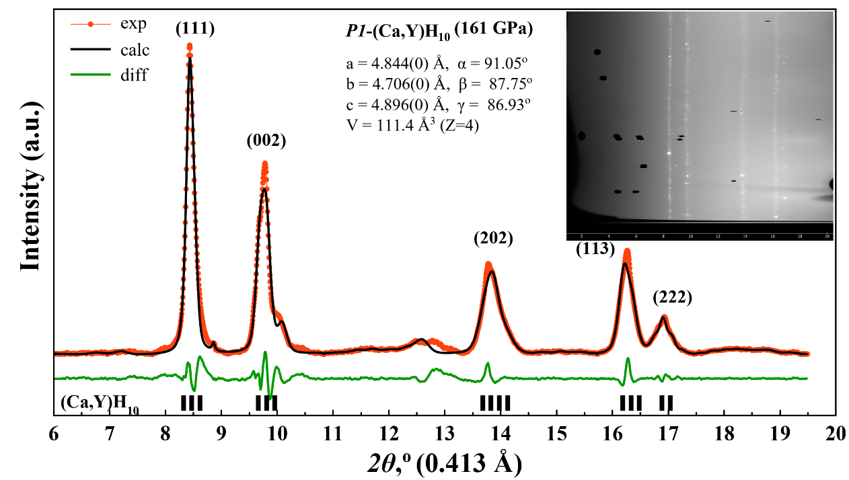

**Figure 19.** Le Bail refinement of *P1*‑(Ca,Y)H9+x and the experimental XRD pattern at 161 GPa (DAC M2). The experimental data, model fit for the structure, and residues are shown in red, black, and green, respectively.

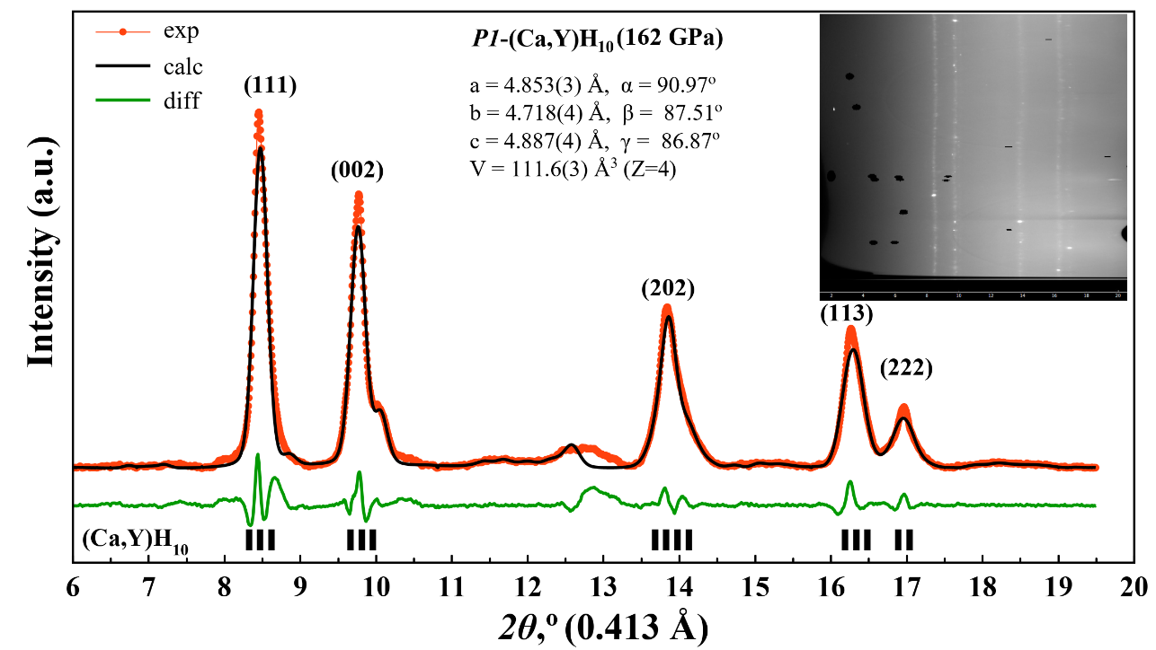

**Figure 20.** Le Bail refinement of *P1*‑(Ca,Y)H9+x and the experimental XRD pattern at 162 GPa (DAC M2). The experimental data, model fit for the structure, and residues are shown in red, black, and green, respectively.

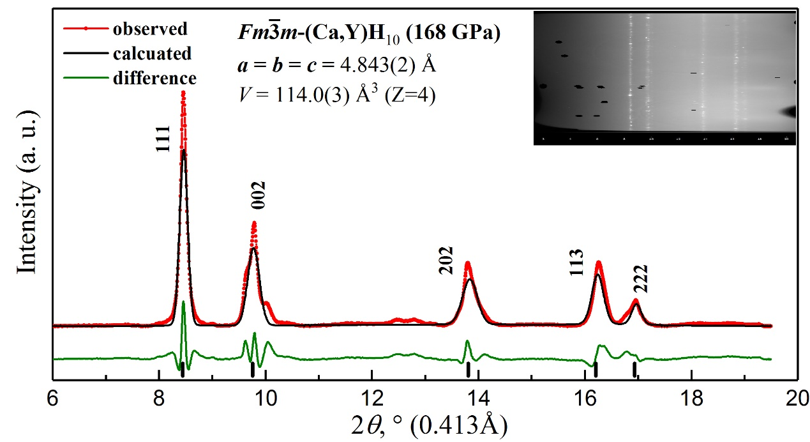

**Figure 21.** Le Bail refinement of *Fm $\overline{3}$ m*‑(Ca,Y)H9+x and the experimental XRD pattern at 168 GPa (DAC M2). The experimental data, model fit for the structure, and residues are shown in red, black, and green, respectively.

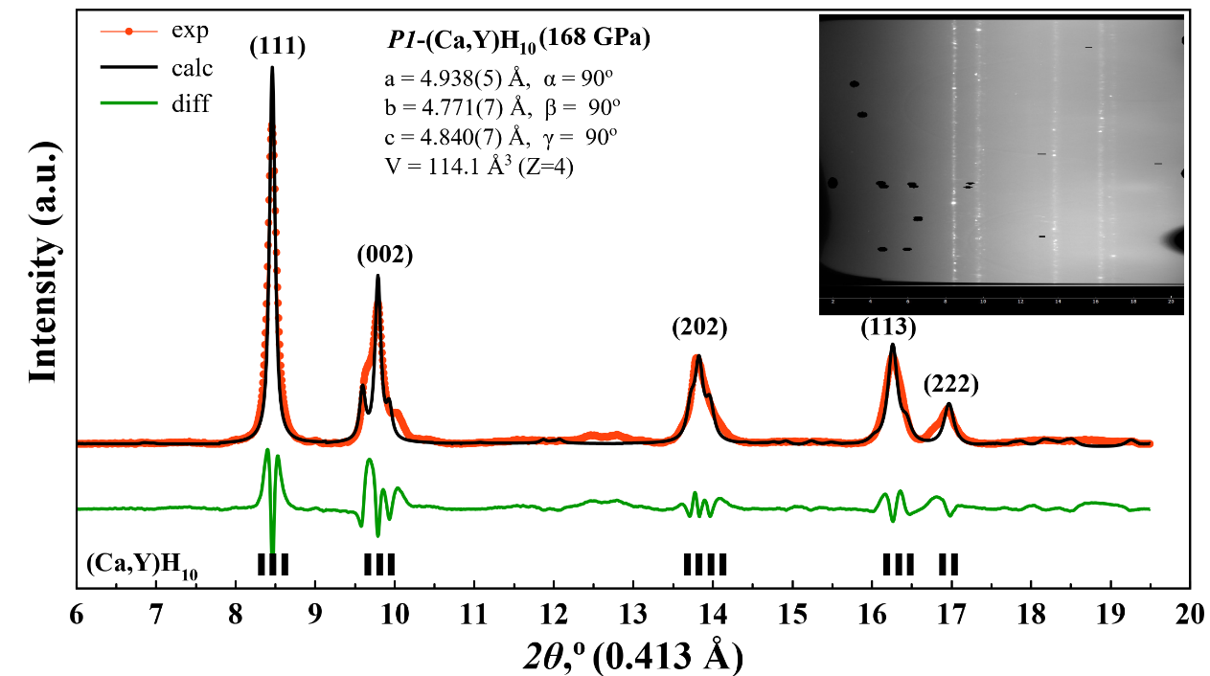

**Figure 22.** Le Bail refinement of *P1*‑(Ca,Y)H9+x and the experimental XRD pattern at 168 GPa (DAC M2). The experimental data, model fit for the structure, and residues are shown in red, black, and green, respectively.